Ex. No:6 Use Sleuth Kit to analyze digital evidence

Description
The Sleuth Kit (TSK) is a collection of command-line tools that allow you to analyze disk images and recover digital evidence. Here's a step-by-step guide to using Sleuth Kit on a Windows machine to analyze digital evidence:
Step 1: Install Sleuth Kit
- Download Sleuth Kit:
  - Visit the official Sleuth Kit website or https://drive.google.com/drive/u/1/folders/1ilSFY7Tqn2L7AjQGhq8yJ8kixc_xTU-v
  - and download the latest version for Windows.
- Install Sleuth Kit:
  - Run the installer and follow the instructions to install Sleuth Kit on your Windows machine.
Step 2: Acquire the Disk Image
Before analysis, you need a disk image of the evidence. This can be an image of a hard drive, memory card, or any other storage device.
- Create Disk Image:
  - Use a tool like FTK Imager or dd to create a bit-by-bit copy of the storage device. Ensure the image is in a format supported by Sleuth Kit, such as .dd, .raw, .img, or .E01.
  - Download the below files from the google drive
    - 4Dell Latitude CPi.E01
    - 4Dell Latitude CPi.E02
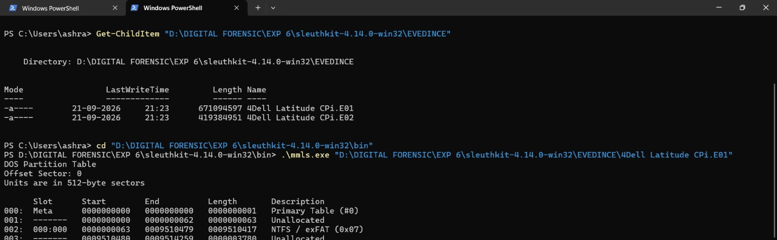
Step 3: Analyze the File System
Use Sleuth Kit tools to analyze the file system and locate evidence.
- Navigate to the Sleuth Kit Directory:
  - Open the Command Prompt and navigate to the directory where Sleuth Kit is installed.
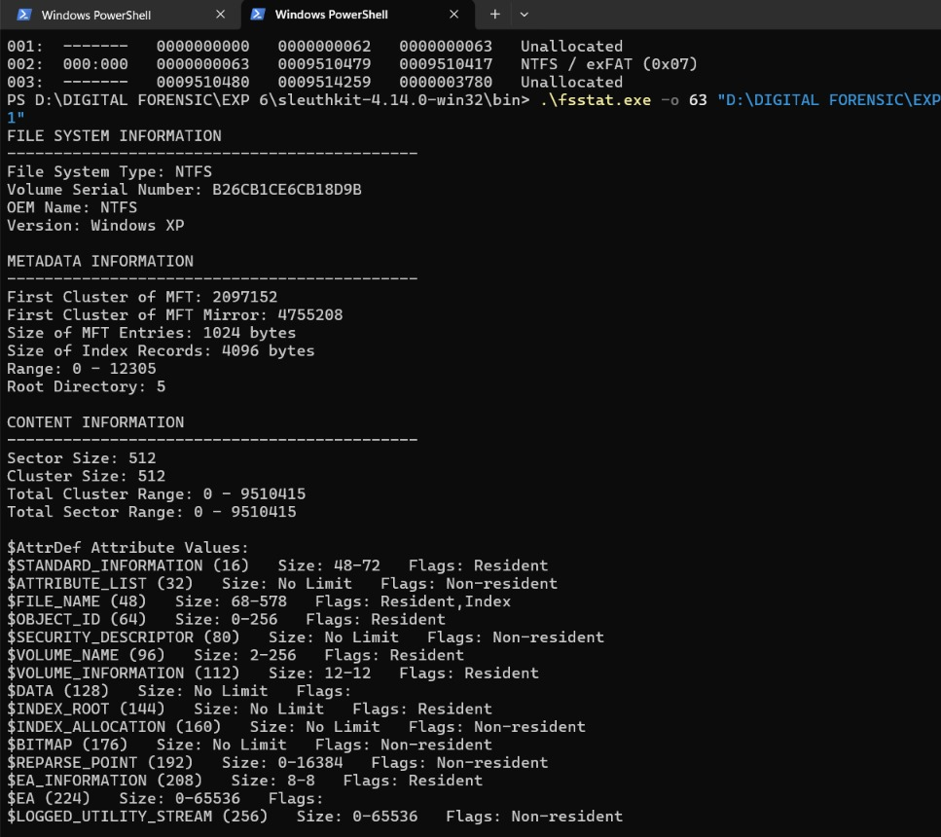
- Identify File System Type with fsstat:
  - Run the command:
arduino
fsstat [image file] > filesystem_info.txt
- This command outputs information about the file system, which is crucial for understanding the structure of the disk.
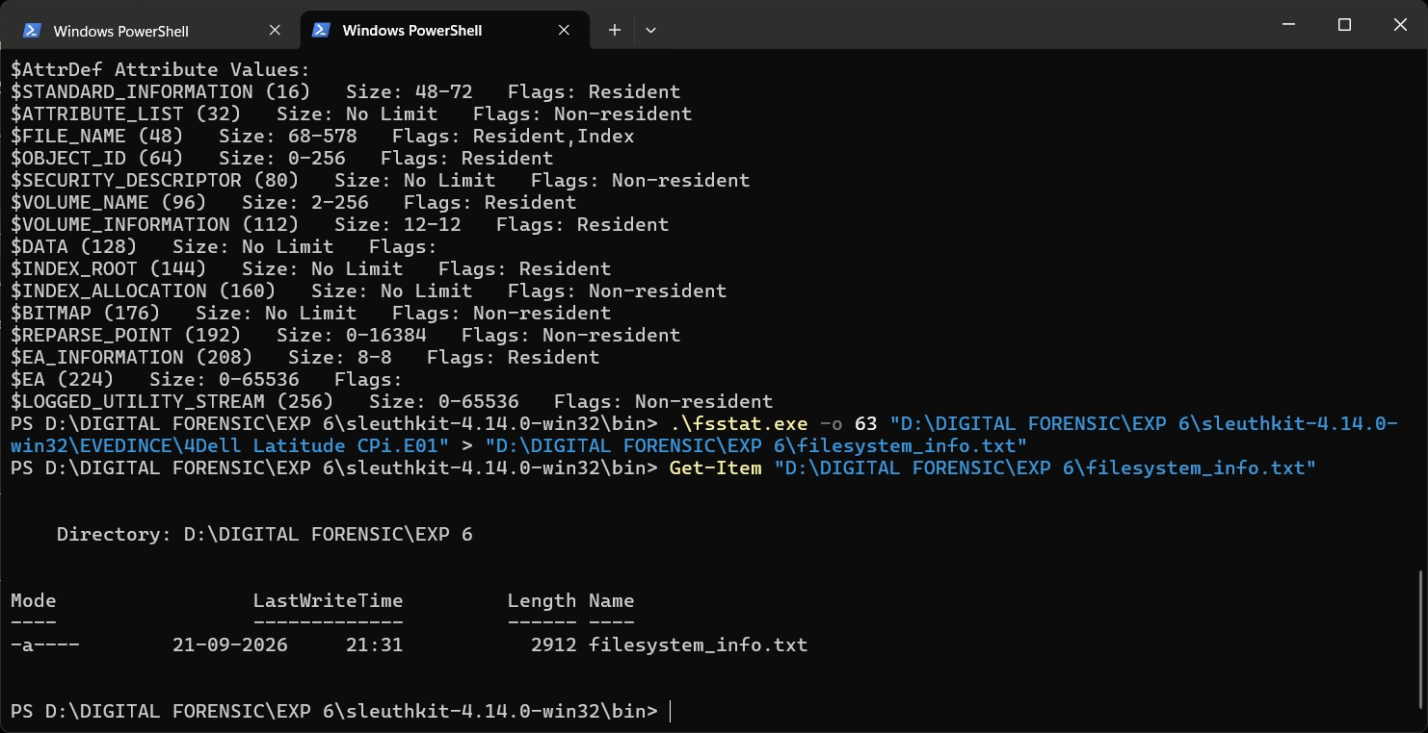
- List Partitions with mmls:
  - Run the command:
arduino
mmls [image file] > partitions.txt
- This command lists the partitions within the image file.
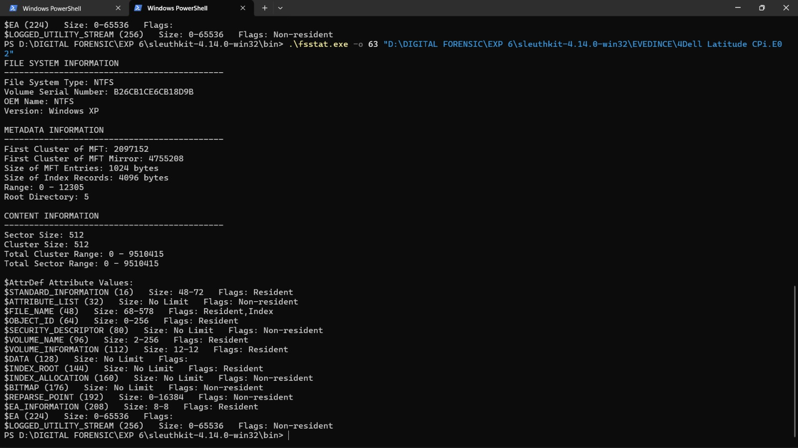
- Analyze File System with fls:
  - Run the command:
arduino
fls -r [image file] > file_list.txt
- This command recursively lists files and directories in the file system, showing their metadata.
- Recover Deleted Files with icat:
  - To extract a specific file, use icat:
css
icat [image file] [inode number] > [output file]
- Replace [inode number] with the inode of the file you want to recover, which you can find from the fls output.
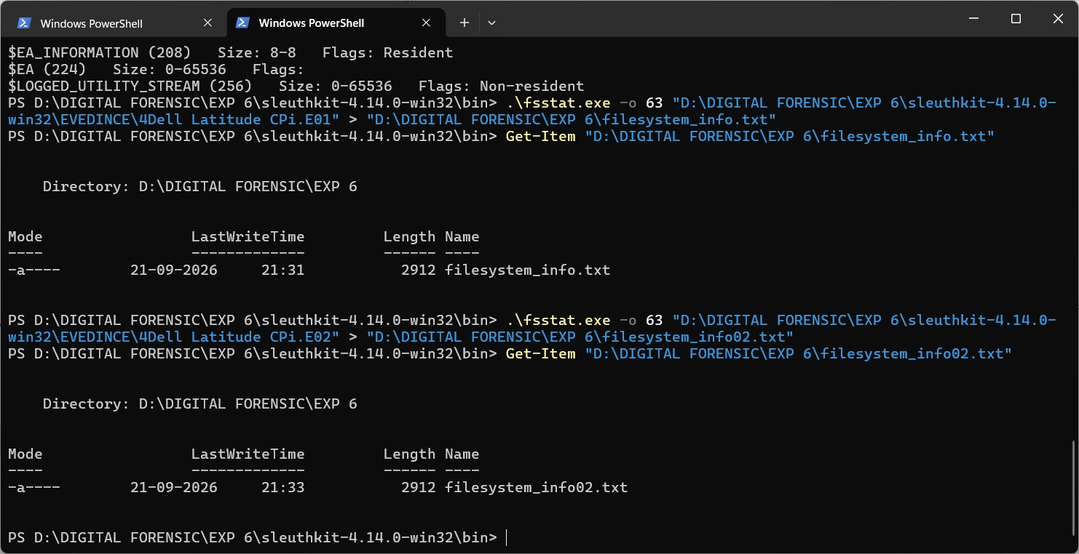
Step 4: Analyze Metadata
Extract metadata from files to understand more about the file's history.
- View Metadata with istat:
  - Run the command:
css
istat [image file] [inode number] > metadata_info.txt
- This provides detailed information about a file, including timestamps, size, and allocation status.
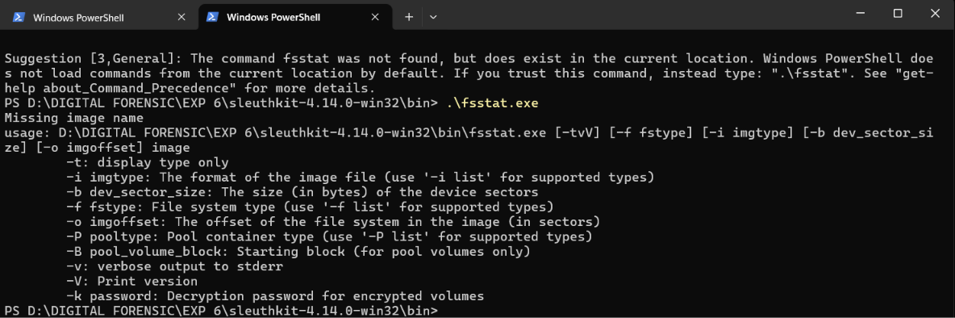
Step 5 Timeline Analysis (Optional)
Creating a timeline of file activity can be crucial in an investigation.
- Create Timeline with mactime:
  - Generate a body file using fls:
css
fls -m / -r [image file] > body.txt
- Then create the timeline:
css
mactime -b body.txt > timeline.txt
- The timeline includes MAC (Modified, Accessed, Changed) times of files.
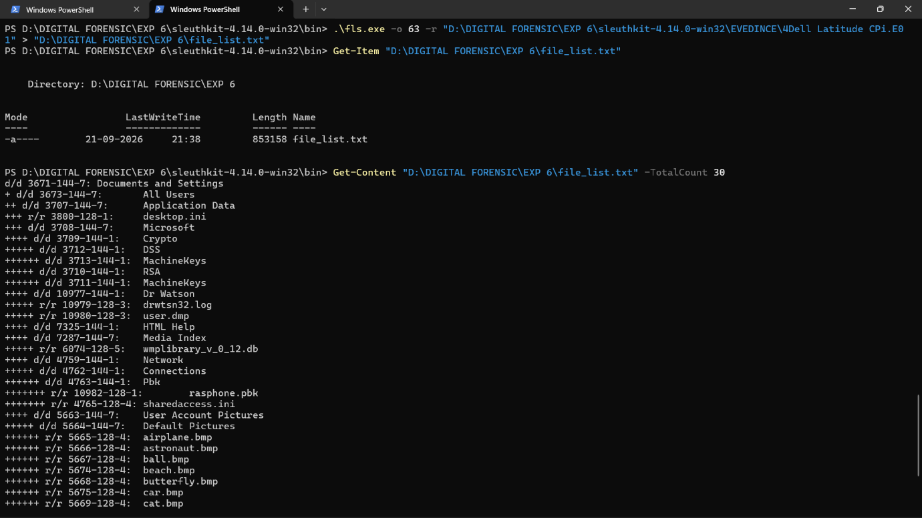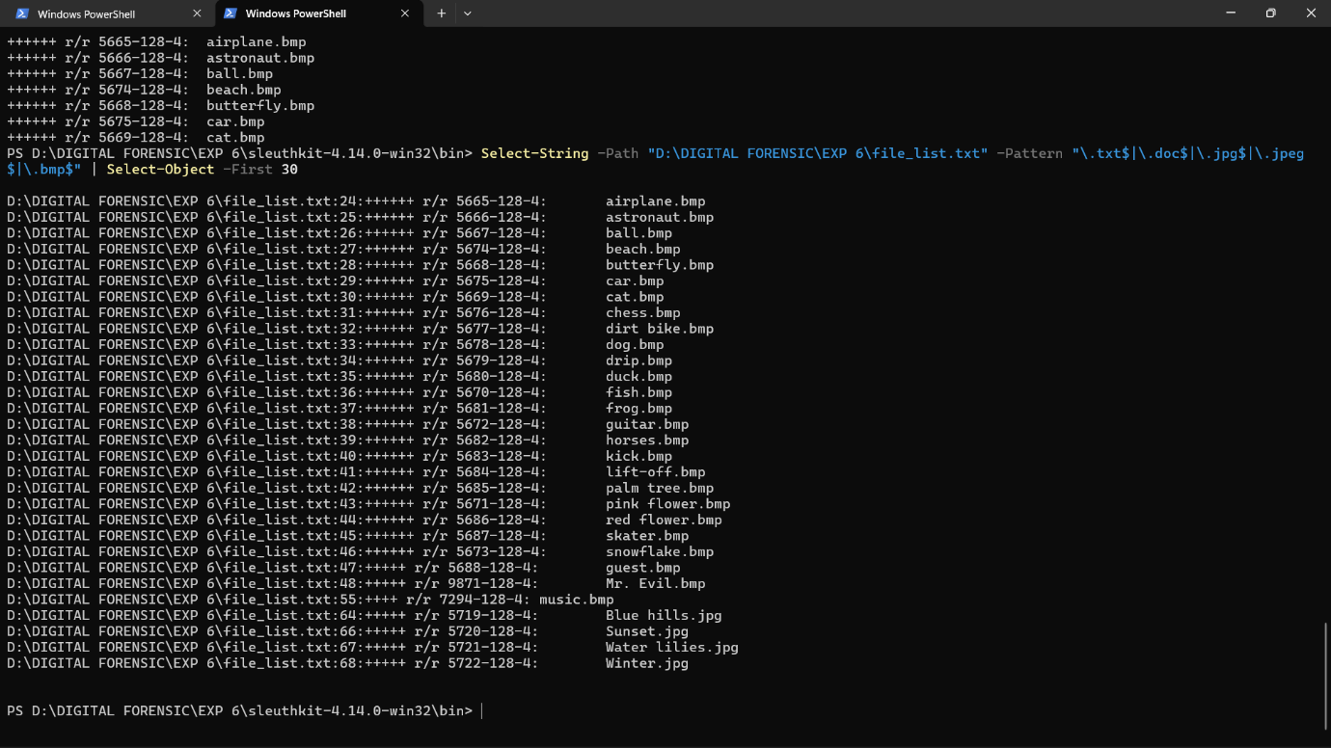
Step 6: Generate a Report
Document your findings by compiling all the data into a comprehensive report.
- Compile the Data:
  - Gather all the output files (e.g., filesystem_info.txt, partitions.txt, file_list.txt, metadata_info.txt, timeline.txt).
- Analyze and Document:
  - Review the findings, highlight important evidence, and write a report summarizing the investigation's results.
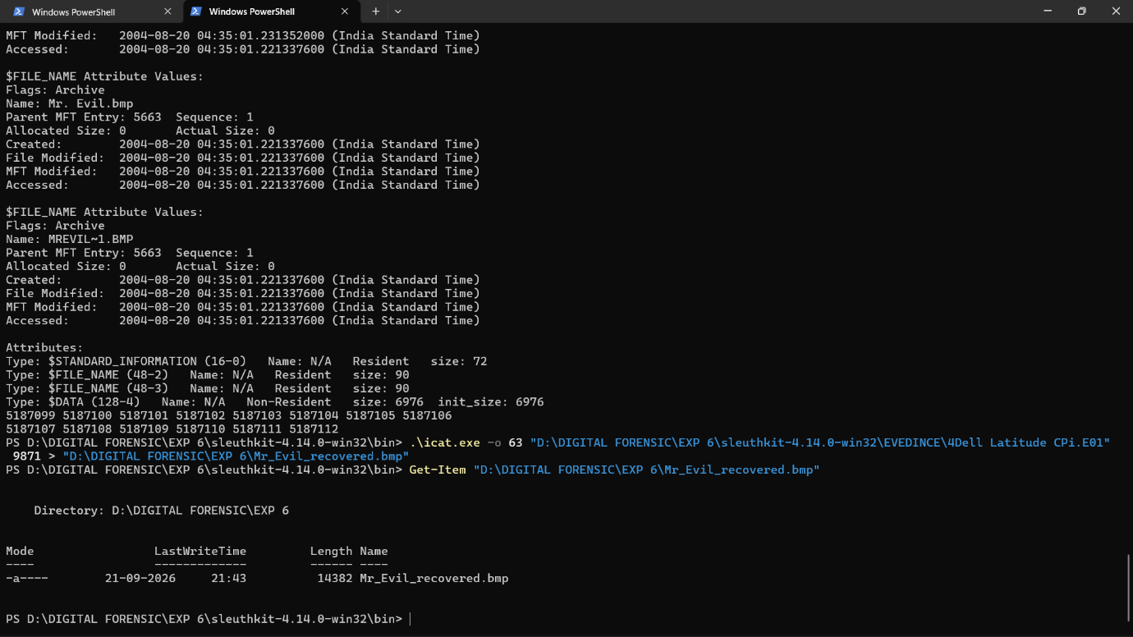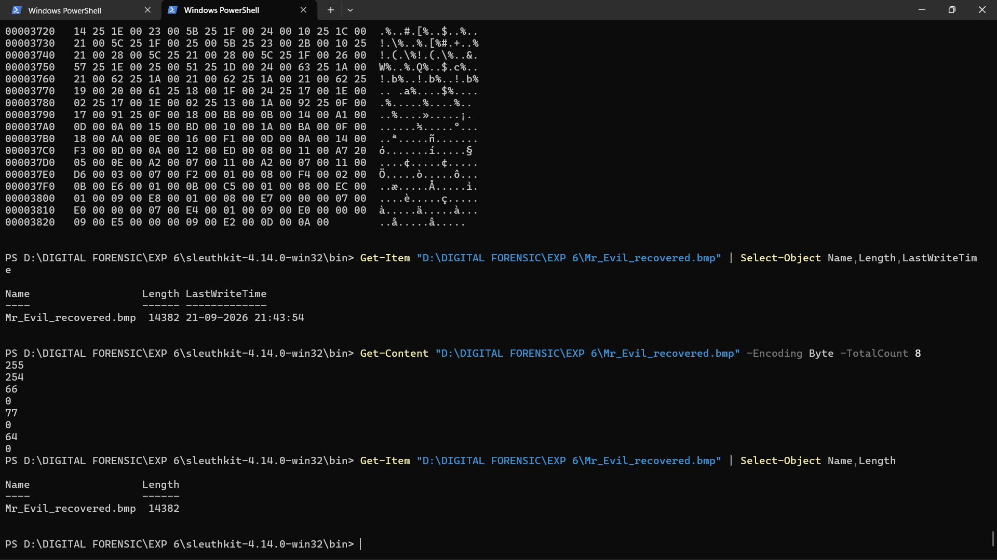
Step 7: Finalize and Store Evidence
Ensure that all evidence and reports are securely stored.
- Archive Evidence:
  - Use a secure method to archive the disk image and analysis results, ensuring integrity and confidentiality.
- Store Securely:
  - Store the archived data in a secure location, following the chain of custody procedures.
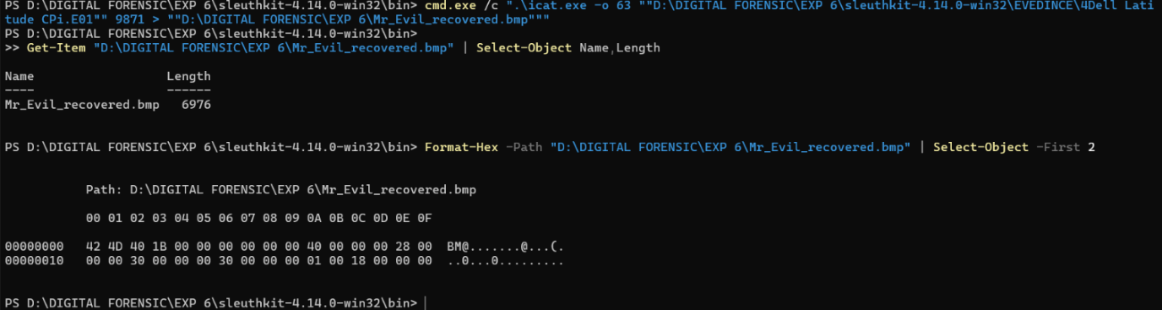
By following these steps, you can use Sleuth Kit on a Windows machine to effectively analyze digital evidence and extract crucial information for your investigation.

